Week 1 - Day 1: Assignment

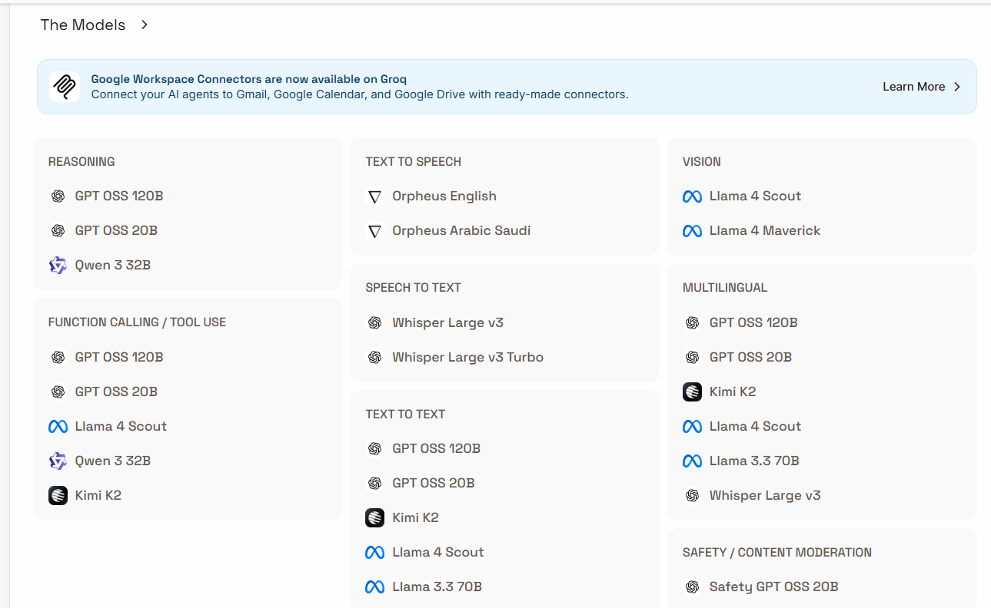

REASONING MODELS
(Used for thinking, problem-solving, coding, chat)

🔹 GPT OSS 120B
From OpenAI (open-source style release)
Use for:
- Complex reasoning
- Coding
- AI agents
- Advanced chat
👉 Most powerful reasoning model in Groq.

🔹 GPT OSS 20B
Use for:
- General chatbots
- Faster responses
- Lower cost apps
👉 Smaller & faster than 120B.

🔹 Qwen 3 32B
From Alibaba
Use for:
- Logical reasoning
- Coding
- Math tasks
- AI assistants
👉 Very strong at structured tasks.

FUNCTION CALLING / TOOL USE
(Used when AI needs to call APIs, tools, or automation)

Models:
- GPT OSS 120B
- GPT OSS 20B
- Llama 4 Scout
- Qwen 3 32B
- Kimi K2
👉 These are best for:
- AI agents
- Automation workflows
- Calling APIs
- Integration with software

TEXT-TO-SPEECH MODELS
(Convert text → human voice)

🔹 Orpheus English

🔹 Orpheus Arabic Saudi
Use for:
- Voice assistants
- Audio narration
- AI phone bots

SPEECH-TO-TEXT MODELS
(Convert audio → text)

🔹 Whisper Large v3

🔹 Whisper Large v3 Turbo
From OpenAI
Use for:
- Transcription
- Meeting notes
- Voice commands
👉 Turbo = faster version.

VISION MODELS
(Understand images)

🔹 Llama 4 Scout

🔹 Llama 4 Maverick
From Meta
Use for:
- Image analysis
- Document reading
- OCR tasks
- Visual AI apps

MULTILINGUAL MODELS
(Work in many languages)

Included Models:
- GPT OSS 120B
- GPT OSS 20B
- Kimi K2
- Llama 4 Scout
- Llama 3.3 70B
- Whisper Large v3
👉 Best for:
- Translation
- Global chatbots
- Multi-language AI apps

TEXT-TO-TEXT MODELS
(General AI — input text → output text)

🔹 GPT OSS 120B / 20B
General reasoning & chat

🔹 Kimi K2
From Moonshot AI
👉 Excellent for long-context documents.

🔹 Llama 4 Scout / Llama 3.3 70B
From Meta
👉 Strong general AI models.

SAFETY / CONTENT MODERATION

🔹 Safety GPT OSS 20B
Use for:
- Detect harmful content
- Moderation filtering
- AI safety checks

SIMPLE MEMORY TIP
Category | Purpose
Reasoning | Thinking & coding
Function Calling | Automation & AI agents
Text-to-Speech | AI voice
Speech-to-Text | Audio transcription
Vision | Image understanding
Multilingual | Many languages
Text-to-Text | General AI
Safety | Content filtering

Week 1 – Day 2 : Assignment

PART 1 — OPENROUTER MODELS

Context Window
= Total memory capacity of a model
(Input tokens + Output tokens combined)

✅ Input Tokens
Text you send to the model.
Examples:
- Prompt
- Question
- Document

✅ Output Tokens
Text generated by the model as response.

OPENAI MODELS (3 Models)
From OpenAI

1 GPT-4o

Context Window
👉 128,000 tokens

Max Output Tokens
👉 16,384 tokens

Input Tokens
👉 Up to ~128K (within context limit)

Use
- Chatbots
- Coding
- Multimodal AI
📌 It is OpenAI’s flagship versatile model.

2 GPT-4 Turbo

Context Window
👉 128K tokens

Output Tokens
👉 ~4K–16K depending on usage

Use
- Fast reasoning
- Coding
- Automation

3 GPT-3.5 Turbo

Context Window
👉 16K tokens

Output Tokens
👉 ~4K tokens

Use
- Basic chatbots
- Low-cost AI apps

CLAUDE 3 MODELS (Anthropic)
From Anthropic

1 Claude 3 Haiku
Context Window:
👉 ~200K tokens
Output Tokens:
👉 ~4K–8K
Use:
- Fast tasks
- Cheap AI apps

2 Claude 3 Sonnet
Context Window:
👉 ~200K tokens
Output Tokens:
👉 ~8K
Use:
- Balanced reasoning
- Business AI

3 Claude 3 Opus
Context Window:
👉 200K – up to 1M tokens
Output Tokens:
👉 Large output support
Use:
- Deep analysis
- Long documents
- Research

QWEN 3 MODELS
From Alibaba

Qwen 3 32B
Context Window:
👉 ~40K – 131K tokens
Output Tokens:
👉 ~8K tokens
Use:
- Coding
- Math reasoning
- Enterprise AI

PART 2 — GROQ MODERATION MODELS
From Groq

🔹 1. GPT-OSS Safeguard 20B

Context Window
👉 Not publicly fixed (reasoning safety model)

Purpose
- Policy-based moderation
- Custom safety rules
- Trust & compliance
Groq lists it as a policy-following safety model.

🔹 2. Llama Guard 4 (12B)
From Meta

Context Window
👉 131,072 tokens

Max Output Tokens
👉 1,024 tokens

Use
- Harmful content detection
- AI moderation
- Safe chat filtering
It is a multimodal safety model for moderation tasks.

🔹 3. Llama Guard 3 (8B)

Context Window
👉 8,192 tokens

Output Tokens
👉 ~4,096 tokens

Use
- Content filtering
- Safety classification

🔹 4. Prompt Guard 2

Context Window
👉 512 tokens

Output Tokens
👉 512 tokens

Use
- Detect prompt injection
- Prevent jailbreak attacks

